

Email Encryption

Lakeland Care Inc. (LCI) has implemented an email encryption system designed to protect emails sent to recipients outside of LCI’s email network.

This software will encrypt emails and any attachments, potentially including sensitive data such as member names, social security numbers, or terms which may indicate the presence of

information protected under HIPAA privacy rules.

**Opening a Secure Email**

* 1. As the recipient, first click: “Read the message”

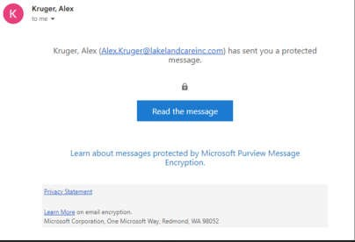

* 1. Next, there will be prompt to request a one-time passcode that will be sent to the recipient’s email address.

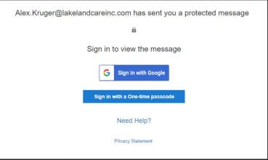

* 1. The next screen will be the confirmation the one-time passcode has been sent.

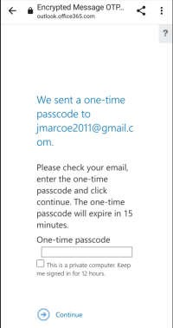

* 1. The recipient will need to open the new email to obtain the one-time passcode. Then, enter the passcode in the encrypted message email. Then click **Continue**.

**\*Please note: This is a sample number; the code will be unique each time.**

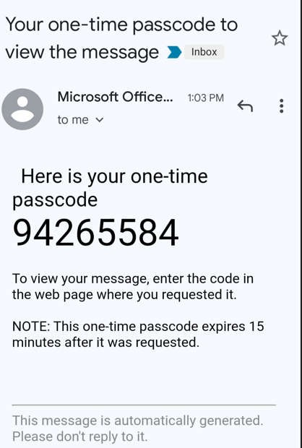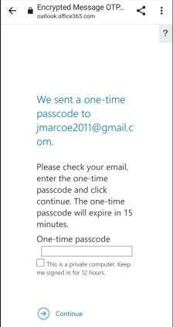

* 1. After successfully entering the one-time passcode, the recipient will be able to open the email and any attachments.

